Shipping Address Label option

Table of Contents

Prepared By 1

Step 1: Setup CDC 1

Step 2: Generate Report 2

## 

## Prepared By

|  |  |  |  |
| --- | --- | --- | --- |
| Contact name | Contact Number | Tieline | Type of Coverage |
| Ummi | +60126757505 | N/A | N/A |
|  |  |  |  |
|  |  |  |  |

## Step 1: Setup CDC

Setup Collection & Delivery Center for customers:

Avon Order Management🡪Account Management🡪Customers

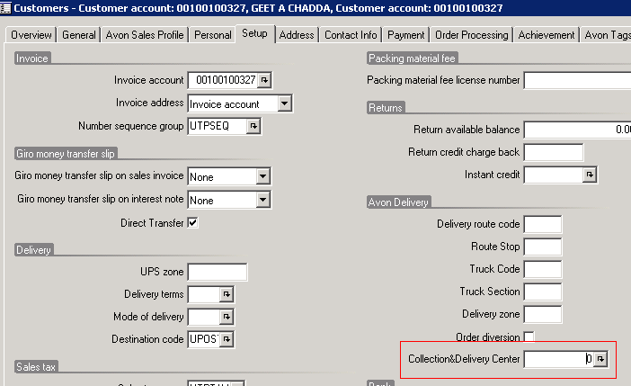

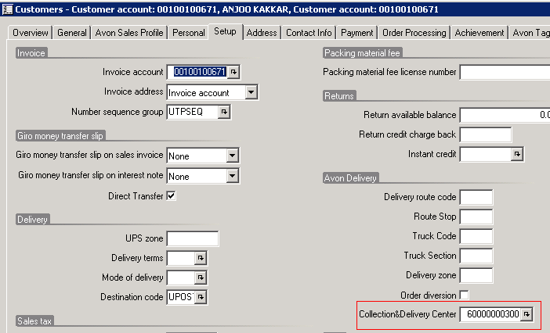

## Step 2: Generate Report

Avon Order Management🡪Reports🡪Shipping Address Labels(Additional New Option)

